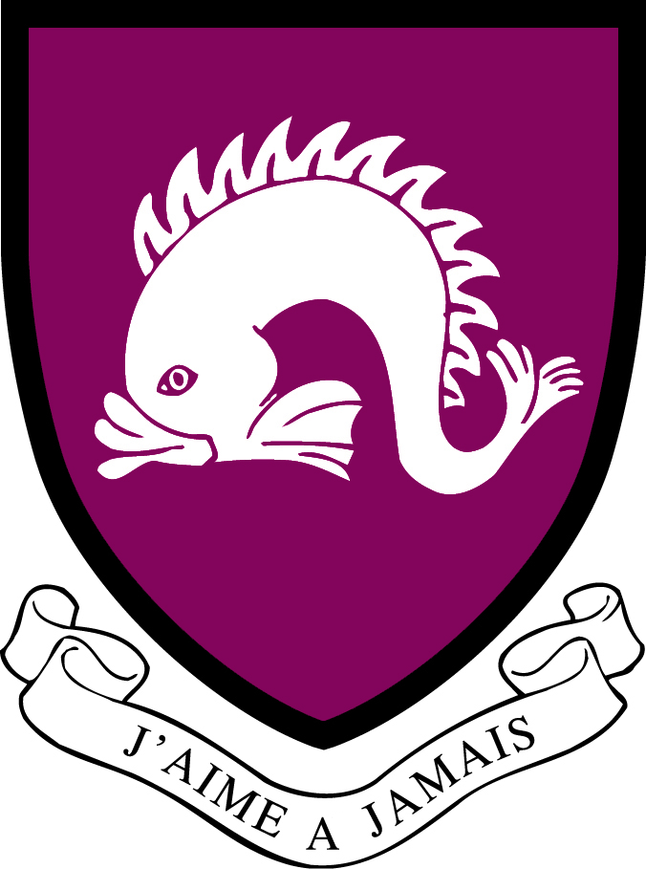
Northbourne Park School
Job Description

Job Title: Head of Modern Languages Department: Modern Languages

Location: Prep / Pre-Prep School Reporting to: Director of Studies.
Overall Purpose of the Job:
- Lead and manage the Northbourne Park Languages Department.
- Deliver an exciting and adventurous core curriculum across the Pre-Prep and the Prep Schools.

Key Responsibilities
- Promote the vision and aims of the school and make a positive contribution to the leadership and management of the school
- Encourage high standards of teaching and learning and lead by example; actively remain up to date with developments in the subject
- Support the strategic planning of the school and contribute to the School Development Plan; produce, implement and review an annual Departmental Development Plan
- Design and implement an appropriately broad, inspiring, rigorous and differentiated Languages curriculum for every pupil
- Manage all aspects of the languages curriculum, subjecting it to regular review, formulating and revising Schemes of Work, including in accordance with requirements of the ISEB for examination at 13+, including Scholarship
- Liaise with the Pre-Prep and other colleagues to ensure progression in Languages throughout the Pre-Prep and the Prep Schools
- Develop and promote the subject throughout the school and media e.g. whole school initiatives, event days, competitions, House Events, newsletters etc
- Support the development of best classroom practice through monitoring planning, lesson observation, book looks and leading staff INSET within the subject
- Maintain an overview of assessment procedures within the department, leading moderation meetings as appropriate
- Monitor the teaching of pupils with Additional Needs and liaise with Head of Learning Support where appropriate

Management of Resources
- Manage the Languages budget and ensure appropriate, diverse and well-maintained resources are available

General requirements
- Fully endorse, understand and exercise your roles and responsibilities contained within the NPS Health and Safety Policy and Handbook as published on the Intranet
- Act within the NPS Professional Standards for Teachers Policy
- Promote and safeguard the welfare of pupils and staff according the School’s Health and Safety, Fire Safety, Child Protection and CLEAPSS regulations and guidelines.
- Fulfil other reasonable duties as directed by the Headmaster
- Attend annual District 2 IAPS meetings and where possible co-ordinate them

This job description is subject to review and change as necessary.

Decision Making Responsibilities
This is a Head of Department position and the post holder is responsible and accountable for the
running of a department, and required to work independently but within policy, professional
standards and budgetary limits.

Personal Specification (Knowledge, Skills & Attributes)
Essential requirements for the role:
Degree in either French or Spanish, or a native French or Spanish speaker
Qualified Teacher status
Ability to communicate clearly and effectively
Flexible and proactive attitude to work
ICT competent
High standard of personal presentation

Desirable requirements:
Experience as a Head of Department
Experience working in an IAPS Boarding School

Safeguarding
Northbourne Park School is committed to safeguarding and promoting the welfare of children. Candidates will be required to complete an application form and produce original documentation of certificates and degree qualifications. An enhanced DBS clearance check will be undertaken for the successful candidate. All staff members at the School are expected to fulfil their obligations and responsibilities in safeguarding and promoting the welfare of children.

Updated January 2025

