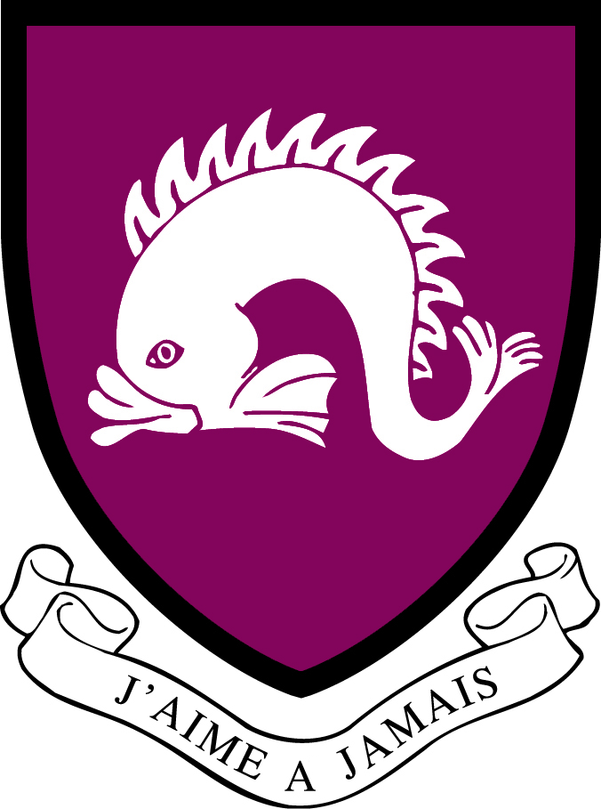
Northbourne Park School
Job Description

Job Title: Residential Boarding Assistant
Location: Prep and Pre –Prep School
Duration: From September 2025 to July 2026 with option to extend.

Reporting to: Head of Boarding for boarding matters and the Head teacher for school matters
Overall Purpose of the Job:
- Assist with boarding, sport, teaching and activities in the Prep and Pre-Prep schools.
- Support the pupils in their School lives.
- Assist with the July 2025 Northbourne Park International Language Centre.
- This is a residential position for the better performance of duties. The position holder is provided with accommodation and school meals during term time to be taken in the school dining hall.
- Enjoy a wide range of responsibilities and challenges throughout the year.

Principal Responsibilities:
- Be an active member of the boarding team, undertaking allocated duties including overnight and weekend duties and accompanying the children back and forth to Paris and London.
- Act as classroom support during lessons in both the Prep and Pre Prep.
- Assist with games, clubs and other out of class areas such as educational, sporting and cultural trips and visits.
- Support pupils with SEND
- Fully endorse, understand and exercise your roles and responsibilities contained within the NPS Health and Safety Policy and Handbook as published on the Intranet.
- Promote and safeguard and welfare of pupils and staff according the School’s Health and Safety, Fire Safety, Child Protection and CLEAPSS regulations and guidelines.
- Fulfil other reasonable duties as directed by the Head teacher.

Decision Making Responsibilities:
Residential Boarding Assistants are required to work using their own discretion or judgement under general guidelines, but should liaise with other members of staff for decisions. The Head teacher meets with Graduates and Gaps regularly, and Boarding Meetings are held weekly.

Personal Specification (Knowledge, Skills & Attributes)
Essential requirements for the role:
- An excellent and enthusiastic role model who wants to pass on their skills to young people
- Able to work with effectively within the extended team of staff in each department
- Ability to communicate clearly and effectively
- High standard of personal presentation

Desirable requirements:
- Prior involvement in working with young people
- A degree in a relevant subject
- Good ICT skills

Safeguarding
Northbourne Park School is committed to safeguarding and promoting the welfare of children. Candidates will be required to complete an application form and produce original documentation of certificates and degree qualifications. An enhanced DBS clearance check will be undertaken for the successful candidate. All staff members at the School are expected to fulfil their obligations and responsibilities in safeguarding and promoting the welfare of children.
Updated January 2025

